**Team FBJP**: Francy Fu, Bill Hibner, Jim Cloud, Patrick Yu

**Background:** We are very interested in safety of Washington University students as they travel to and from class in St Louis and St Louis County. This visualization tool will help students to make better decisions on which route to take to avoid high accident locations and times.

**Project Proposal:** Our team will compare traffic accident data from the Missouri Highway Patrol Office to determine:

1. Where accidents occur
2. Time of day when accidents occur
3. Type of accidents: vehicle, bicycle, pedestrian
4. Severity of accidents

**Primary Data Source:** State of Missouri STARS Reporting: <https://www.mshp.dps.missouri.gov/TR15Map/Search>

Screen shot here:

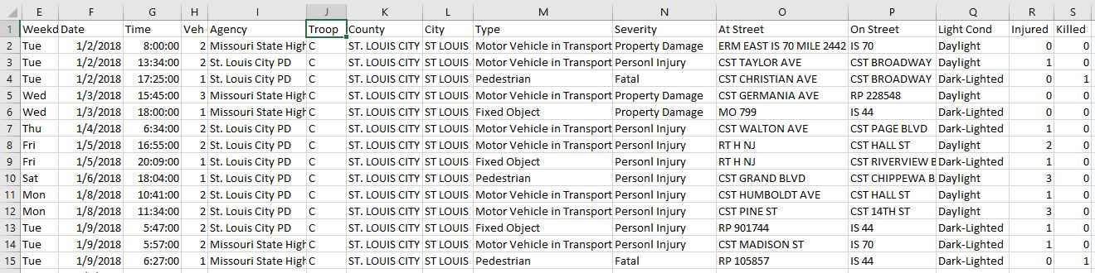

Example of visualizations:

